To determine whether a Machine Learning (ML) or Deep Learning (DL) model is correctly working, you should not rely only on high accuracy. You need to evaluate it from several perspectives.
Before evaluating the model, verify:
- Training, validation, and test sets are properly separated.
- No data leakage exists between train and test sets.
- Classes are correctly labeled.
- Missing values and outliers are handled appropriately.
- Class imbalance is identified.
- For image data, check that images and labels correspond correctly.
- Apply preprocessing consistently to train, validation, and test data.
A very common problem is data leakage, where information from the test set indirectly reaches the training process. This can produce unrealistically high performance.
- Check training and validation behavior
For a DL model, plot:
- Training loss vs. epochs
- Validation loss vs. epochs
- Training accuracy vs. epochs
- Validation accuracy vs. epochs
You generally want to see something like:
Good model
Training Loss ↓
Validation Loss ↓
Training Accuracy ↑
Validation Accuracy↑
If training accuracy continues increasing while validation accuracy stops improving or decreases:
Training Accuracy 99%
Validation Accuracy 82%
this is a strong indication of overfitting.
If both training and validation performance remain poor, the model may be underfitting.

2. Evaluate on an unseen test set
The most important test is performance on data that the model has never seen during training or model

4. Check the confusion matrix
For example:
Actual / Predicted | Disease | Normal
Disease | 95 | 5
Normal | 3 | 97
This tells you much more than simply saying "accuracy = 96%."
For medical diagnosis, for example, you should specifically examine false negatives. A model with high accuracy but many missed disease cases may not be clinically useful.

5. Check ROC-AUC
ROC-AUC measures how well the model separates classes across different classification thresholds.
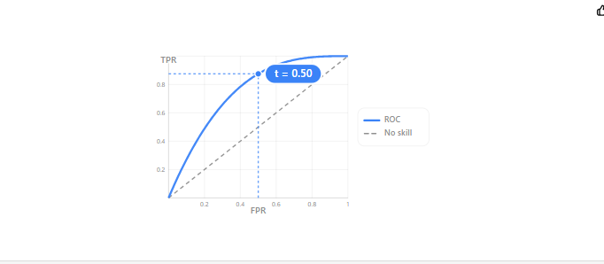

AUC | General interpretation
0.50 | No discrimination
0.60–0.70 | Poor
0.70–0.80 | Fair
0.80–0.90 | Good
0.90–1.00 | Excellent
However, AUC close to 1.0 does not automatically mean the model is correct. You still need an independent test set and other analyses.

6. Check for overfitting
For example:
 | Training | Validation/Test
Accuracy | 99.8% | 82.5%
This model is probably overfitting.
But:
 | Training | Validation/Test
Accuracy | 96.5% | 95.8%
This is much more reassuring.
For DL, also inspect the loss curves.

- An ablation study is an experiment used to determine which components of your proposed model actually contribute to its performance.
Ablation study = Remove or disable one component at a time and observe how the model performance changes.
This is especially important when you propose a new architecture, preprocessing method, feature-selection method, loss function, attention mechanism, ensemble strategy, or optimization technique.

Example
Suppose your proposed medical-image model contains:
- CNN backbone
- Attention module
- Data augmentation
- Focal loss
- Feature fusion
- Proposed preprocessing method
Your complete model is:
CNN + Attention + Augmentation + Focal Loss + Feature Fusion
Now remove one component at a time.
Experiment | Attention | Augmentation | Focal Loss | Feature Fusion | Accuracy | F1 | AUC
Baseline CNN | ✗ | ✗ | ✗ | ✗ | 91.20 | 90.85 | 0.942
+ Augmentation | ✗ | ✓ | ✗ | ✗ | 93.10 | 92.80 | 0.957
+ Attention | ✓ | ✓ | ✗ | ✗ | 94.35 | 94.10 | 0.968
+ Focal Loss | ✓ | ✓ | ✓ | ✗ | 95.20 | 95.05 | 0.976
Full Proposed Model | ✓ | ✓ | ✓ | ✓ | 96.75 | 96.60 | 0.989
This demonstrates that the individual components contribute to the final performance.

Why is ablation study important?
It answers the researcher's question:
"Why does my proposed model perform better?"
Without ablation, a reviewer may ask:
"Your model achieves 96.75%, but which component is responsible for this improvement?"
An ablation study provides experimental evidence.

